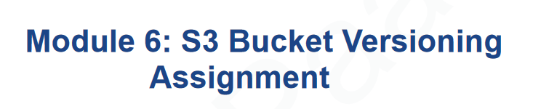

Now Continue to 1st Assignment

Select the bucket you want to manage versioning for.

Click on the "Bucket Properties " tab.

Under "Versioning", you will find options to:

Enable: Click the "Enable" button and choose the option to configure Multi-Factor Authentication (MFA) Delete if desired. Click "Save"

NowShowing show version is disabled

Enable the Show version

**Upload the same file again as versioning is enabled.**

**Click on upload and upload the two files which are showing again**

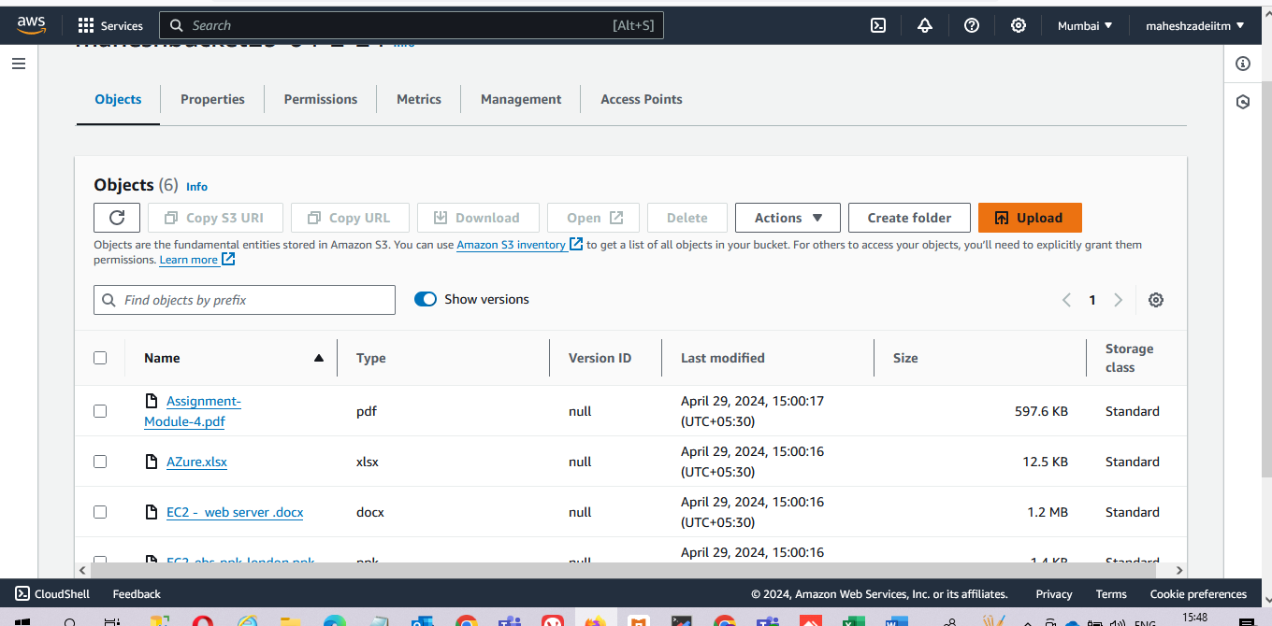

**Click on upload now**

**Now go to object again and check the versioning is working or not**

**Version ID is showing for both the files**

**Hence versioning is working now .**

**Pls check and update.**